APPLICATION FORM FOR PRESS REGISTRATION TO THE  NATO MILITARY COMMITTEE CONFERENCE  Split , 16-18 September 2016 | 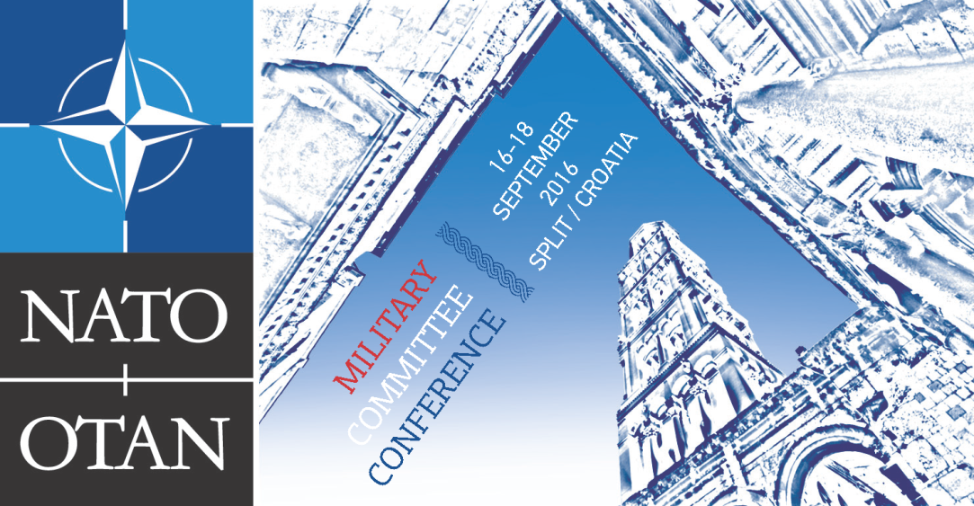
The completed form should be sent to:
Address: MORH, SSOJI, Trg kralja Petra Kresimira IV 1, 10000 Zagreb
Tel: +385 1 4568 008 Fax: +385 1 4568 109
E-mail: infor@morh.hr (Please indicate the subject as ’Registration NATO MCC 2016“)
1. First name
2. Last name
3. Name of media outlet
4. Position/function
5. Contact information  Phone number:  Mobile number: | Fax:  E-mail:  Website:
6. Personal information  Personal identification code:  Date of birth DD/MM/YYYY: | Place of birth:  Country of birth:  Sex: Male [ ] Female [ ]
7. Please indicate on which events you plan to attend:  - Friday 16 SEP (Welcome Ceremony): YES* NO*  - Saturday 17 SEP (Opening Remarks): YES* NO*  - Saturday 17 SEP (Press Conference): YES* NO*  *Delete as applicable |  | 8. Licence plate number and make of personal vehicle:
9. Do you have a valid accreditation of Ministry Of Defence or Foreign Affairs?  Yes [ ] No [ ] |  | 10. Required documents:  ⁭- copy of a passport* [ ]  - copy of a press card * [ ]  *bearing a photograph of a person
Important notice: please send this form NLT 14 SEP 2016, 10.00 am. Only accredited media will get access to the media opportunities.

